Implement Client Server communication model using UDP

Steps involved how to Implement Client Server communication model using UDP below in the following order-
Program 1: A client server-based program using UDP to find if the number entered is even or odd.
Step1 – Write a client program.
Step2 – Write a server program.
Step3 – Program output.
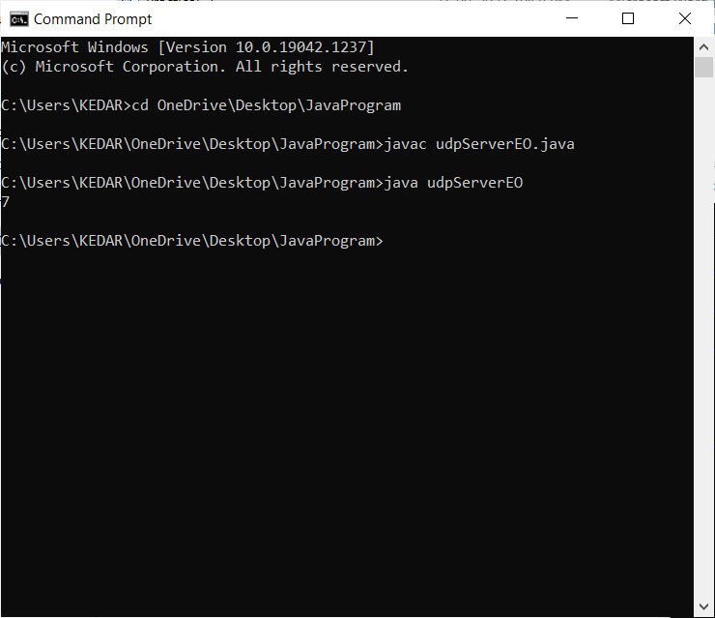
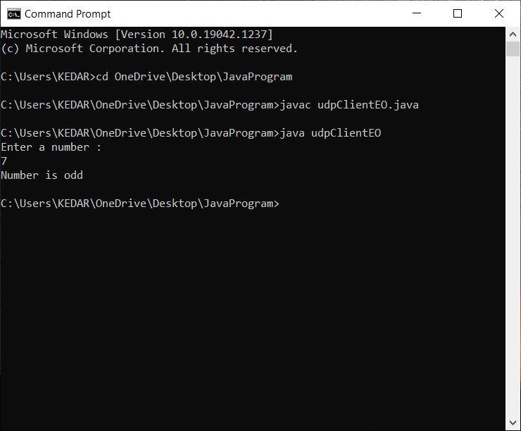

Program 2: A program to implement simple calculator operations like addition, subtraction, multiplication and division

Step1 – Write a client program.
Step2 – Write a server program.
Step3 – Program output.

